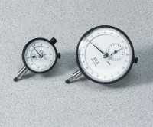 | Mechanical Dial Indicator - 10 mm Range  Code: 88-4080  Product Group: Mechanical Dial Indicators, Pneumatic Consolidation Apparatus, Table Top Consolidation Apparatus

Specification
Range | 10 mm
Divisions | 0.0025 mm
Movement | Counter-clockwise
Face Diameter | 92 mm
Contact Point | Immediate response, up or down; tip movement magnified to indicator hand with minimal friction; 3/16” (5 mm) radius x 1/4” (6 mm) l.
Dials | With continuous graduations and revolution counters.
Measure Movement | Measure movement away from dial case; pointer at zero with stem retracted.
Weight | Net 12 oz. (34 0 g).

