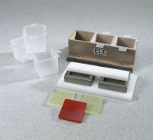 | 2" Cube Test System  Code: 39-0414  Product Group: 2" Cube Test System  Includes cast iron three gang mould, 27 liners, tamping rod, 2 retainer caps, 4 compression pads and utility knife

Specification
Mold Frame | Cast iron; three gang.
Liners | Water tight polypropylene with tabs.
Tamping Rod | Polypropylene.
Retainer Caps | Stainless steel.
Compression Pads | Polyurethane; 1/4â (6.3 mm) thick.
Weight | Net 7 lbs. (3.2 kg).

