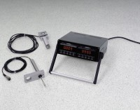 | 2 Channel Digital Readout, Metric  Code: 27-1109/02  Product Group: Digital Load and Displacement Readout, Versa-Loader, Digital Tritest 50 Load Frame  Transducers to be ordered separately. Metric units.

Further Information
110vAC, 50/60 Hz, 1ø.

Specification
Displays | Two, 4-digit red 14 segment LED displays.
Display Units | English models in lbf and inches; Metric models in kN and mm.
Read Rate | Three samples per second; automatic polarity.
Warm-Up Time | 30 minutes for rated accuracy.
Operating Temperature | 32 ÂºF - 12 0ÂºF (0ÂºC - 50ÂºC).
Dimensions | 9.3â w. x 9.3â d. x 3.2â h. (236 x 236 x 81.3 mm).
Weight | Net 8 lbs. (3.6 kg).

