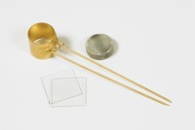 | Le Chatelier Mould  Code: 38-3005  Product Group: General Expansion of Dry Hydrated Lime by the Le Chatelier Method, Soundness of Cement Paste by the Le Chatelier Method, Soundness  Comprising a split cylinder fitted with two indicator stems. The mould is supplied complete with two glass plates and a weight 100 g ±10 g. Three moulds required for each test.

Standards
BS 6463, EN 196-3, EN 459-2

Further Information
**NOT AVAILABLE FOR SALE IN THE USA**

