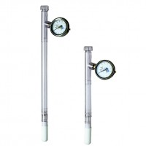 | Dial-Type Gauge Tensiometer 600 mm  Code: 514-022  Product Group: Tensiometers  600 mm Long

Further Information
Requires Part 514-034

