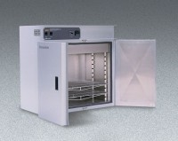 | Forced Convected Oven - 6.9 cu. ft. capacity - 120V  Code: 88-0156/02  Product Group: Forced Convected Ovens  120vAC, 60 Hz, 1ø, 21.6 amps.

Specification
Chamber Size | 30â w. x 18â d. x 22 â h. (76 x 46 x 56 cm); 6.9 ft3 (196 liters).
Overall Size | 36â w. x 24 .5â d. x 36.5â h. (92 x 63 x 93 cm).
Operating Range | 35 Â°C - 204Â°C (95Â°F - 400Â°F).
Weights | 245 lbs. (112 kg).

