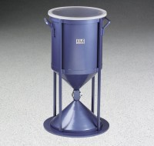 | Sand Density Cone 12"  Code: 29-4350  Product Group: Sand Density Cone, 12"  Includes circular base plate.

Standards
ASTM D4914

Specification
Lower Cone | Flanged; 12 â (305 mm) opening.
Sand Jar | Metal; clear plastic top; with handles.
Finish | Painted.
Weight | Net 42 lbs. (19 kg).

