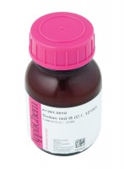 | Red Dye Kerosene Soluble 10G Phial for Colouring Kerosene.  Code: 26-1900  Product Group: Volume Change Measurement  Kerosene soluble red dye to colour the kerosene in the volume change unit (10g phial)

