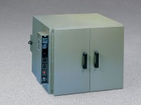 | Bench Oven - Digital PID Controller - 7 cu. ft. capacity - 230V  Code: 88-0140/01  Product Group: Bench Ovens  230vAC, 50/60 Hz, 1ø.

