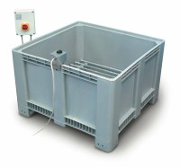 | Large Curing Tank C/W with Circulating Pump Heater/Thermostat Unit and Lower Rack  Code: 34-6575/01  Product Group: Expansion (swell) Test Equipment, Large Curing Tank  This curing tank is supplied complete with a submersible pump, immersion heater/thermostat unit and separate control panel. The tank includes a lower rack as standard and is designed to maintain the temperature at 20 ± 2ºC, providing that the ambient temperature does not fall below 15ºC or rise above 20ºC.

Further Information
**NOT AVAILABLE FOR SALE IN THE USA**
Supplied as specified. For 220 - 240 V AC, 50 - 60 Hz, 1 ph.

Specification
Internal Dimensions | 1040 x 1040 x 605 mm (l x w x h)
Capacity | 650 litres
Rated Power | 2000 watt
Weight | 60 kg

