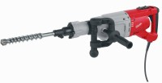 | Vibrating Hammer  Code: 47-0455/01  Product Group: Percentage Refusal Density (PRD)  Accessory - suitable for compacting asphalt samples.

Standards
EN 12697-32, EN 13280-4, BS 598-104

Further Information
**NOT AVAILABLE FOR SALE IN THE USA**

