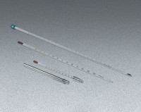 | Glass Laboratory Thermometer - -30° to 120°F x 1.0°; 12” (305 mm) l.  Code: 88-4490  Product Group: Glass Laboratory Thermometers  Contains mercury.

Specification
Weight | Net 3 oz. (85 g).

