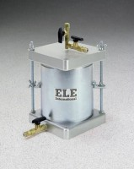 | Compaction Permeameter 4"  Code: 25-0618  Product Group: Compaction Permeameters

Standards
ASTM D5856

Specification
Mould | Machined seamless steel tubing; plated.
Capacity | 1/30 cu. ft.; 4â i.d. x 4.584â h. (101.6 x 11 6.4 mm).
Collar | 2â h. (50.8 mm); machined seamless steel tubing; fits either end of mold; plated.
Top | Cast aluminum; with overflow valve  assembly and water connection.
Base | Cast aluminum; with inlet/outlet fitting.
Porous Stone | 4â diam. x 1/2â thick (101.6 x 12.7 mm). 50-70 permeability rating; 225 micron,  average pore size.
Weights | Net 12 lbs. (5.4 kg).

Spares/Consumables
 | Porous Stone for 25-0618  Code: T-319

