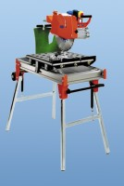 | Diamond Blade  Code: 82-8950/12  Product Group: Masonry Saw  Accessory. Wet cutting. Blade diameter 350 mm, depth of cut 110 mm.

Further Information
**NOT AVAILABLE FOR SALE IN THE USA**

