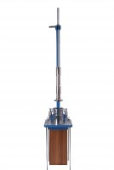 | Compaction Pedestal BS 598  Code: 45-6410  Product Group: Manual Compaction  Comprising a 300 mm sq x 25 mm thick steel plate complete with 4 tie rods and securing nuts. A mould clamp and hammer guide are fitted to the plate. The unit is supplied complete with a laminated hardwood block.

Standards
EN 12697-30

Further Information
**NOT AVAILABLE FOR SALE IN THE USA**

