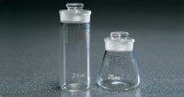 | Hubbard-Carmick Specific Gravity Bottle  Code: 46-2191  Product Group: Hubbard-Carmick Specific Gravity Bottles  Cylindrical type 24 ml.

Standards
ISO 3838, BS 4699, ASTM D70, AASHTO T228

Further Information
**NOT AVAILABLE FOR SALE IN THE USA**

