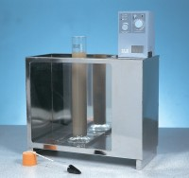 | Constant Temperature Bath 0 to 99.9 Deg.C X 0.1 Deg.C with Led Display and False Base Support.  Code: 24-4865/01  Product Group: Constant Temperature Bath  This compact, bench-top stirrer is used for dispersing soil samples in water for hydrometer analysis. The stirrer is supplied complete with Mixing Paddle and Dispersion Cup. Weight 4 kg.

Further Information
Specially designed for the sedimentation testing of soils and other fine grained material, the bath is supplied with a false bottom to assist in circulation of the bath liquid. Will accommodate six Sedimentation Cylinders.

Specification
Dimensions (l x w x h) | 535 x 210 x 610 mm external
Capacity | Holds up to 6 sedimentation cylinders
Construction | Stainless steel with toughened glass front
Temperature Control | Heater/thermostat/circulation with digital controller unit
Power | 1500 watts
Weight kg | 12

