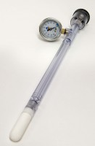 | JET Fill Tensiometer 300 mm  Code: 514-036  Product Group: Tensiometers  300mm Long

Further Information
Requires Part No 514-034

