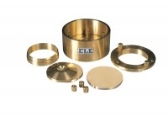 | Consolidation Cell Complete 50mm Diameter Sample.  Code: 25-0455  Product Group: High pressure application consolidation cells and accessories, Pneumatic Consolidation Apparatus, Fixed Ring Consolidation, Table Top Consolidation Apparatus

Specification
Application | High pressure
Specimen Dia | 50 mm
Specimen area | 1963 mm²
Beam ratio | 10:1
Load kg | 1
Stress | 50 kPa
Typical max stress | 8 MPa
Stress for 1 kg m² | 50 kPa
Application | High Pressure
Specimen Diameter | 50 mm
Specimen Area | 1963 mm²
Beam Ratio | 10:01
Load | 1 kg
Stress | 50 kPa
Typical Maximum Stress | 8 MPa
Stress for 1 kg | 50 kPa

Spares/Consumables
50mm Dia Upper and Lower Porous Stones for Use on EL25-0455 Series Cell.
Code: 25-0455/13
Cutting Ring 50mm Cell.
Code: 25-0458

