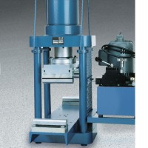 | Flexural Attachment  Code: 37-5528  Product Group: Accu-Tek 250 Series Flexure Attachments, Accu-Tek Touch 250 Series

Standards
ASTM C78, ASTM C293, AASHTO T97

Specification
Loading | Center point or third point.
Blocks | Flexible to keep axes normal to specimen surface at compression point.
Lower Head | Adjusts for beam lengths of 18”, 2121”, 2424”, 30” and 36” (45457, 533533533, 610, 762 and 91414 mm).
Upper Head | Fastens to upper platen by 4 spools.
Weight | Net 175 lbs. (79 kg).

