 | Hveem Stabilometer - California Type  Code: 45-7505  Product Group: Hveem Stabilometer  California Type. Modified version with fixed stage, dual scale gauge (psi/kPa).

Standards
CA 301, CA 366

Specification
Specimen Size | 4â (101.6 mm) diam.
Gauge | Dual scale: 200 psi / 1300 kPa capacity; 1/4% accuracy.
Loading | Diaphragm/piston pump.
Shell | Aluminum-Magnesium; adjustable stage.
Pressure Fluid | 2 qt. hydraulic fluid (included).
Dial Indicator | 1.0â displacement x 0.001â divisions.
Followers | Two included; one 3.985â Â± 0.005â diam.  x 5-1/2â; one 3.95â Â± 0.005â diam. x 5â h.
Weight | Net 55 lbs. (24.9 kg).

Spares/Consumables
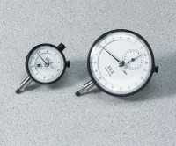 | Dial Indicator - 1.0" Range  Code: 88-4100
Diaphragms
Code: 45-7500/12
Hveem Test Block
Code: 45-7500/10

