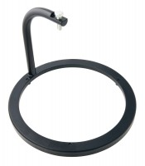 | Swell Tripod  Code: 24-9262  Product Group: Expansion (swell) Test Equipment, Tripod Attachment  For mounting Swell Dial Gauge in position on CBR mould collar.

Standards
ASTM D1883, AASHTO T193

Further Information
Requires dial indicator; not included, order separately

Specification
Construction | Machined, one-piece cast aluminum.
Contact Head | Integral part of ssembly; holds dial indicator.
Construction | 2” l. (50.8 mm) included.
Weight | Net 1 lb. (0.4 kg).

Spares/Consumables
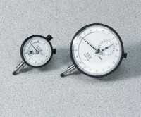 | Dial Indicator - 1.0" Range  Code: 88-4100

