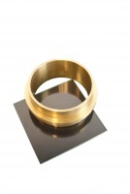 | Vicat Mould  Code: 38-2200  Product Group: Vicat Method, Automatic Vicat  Accessory: manufactured from brass and supplied complete with a ring and glass base plate.

Standards
ASTM C187, ASTM C191

Further Information
**NOT AVAILABLE FOR SALE IN THE USA**

Spares/Consumables
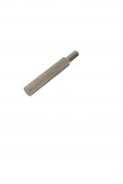 | Consistency Plunger  Code: 38-2010/10

