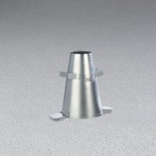 | Metal Slump Cone - English  Code: 34-0108  Product Group: Slump Cones

Standards
ASTM C143, ASTM C192, AASHTO T23, AASHTO T119, ASTM T126

Specification
Construction | Seamless, heavy-gauge spun steel; 0.45" (1.1 mm) min. Thickness.
Finish | Plated for rust and corrosion resistance.
Dimensions | 4" top diam. X 8" bottom diam. (without foot pieces) x 12" h.
Weights | Net 5.5 lbs (2.5kg)

