 | Dial Gauge 25mm Travel X 0.01mm Divisions  Code: 25-4210  Product Group: Axial Displacement, Digital Tritest 50 Load Frame  25 mm travel x 0.01 mm

Standards
BS 1377

Spares/Consumables
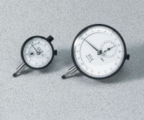 | Dial Indicator - 1.0" Range  Code: 88-4100

