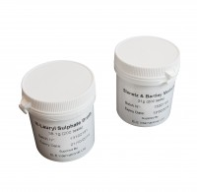 | Slanetz and Bartley Medium. 21G Pack. Sufficient for 200 Tests.  Code: 422-120  Product Group: Microbiological starter packs and consumables  100 grams to make up to approximately 200 tests.

