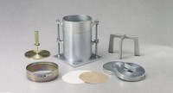 | 9.1Kg (20 Lb) Slotted Surcharge Weight (Cbr).  Code: 24-9248  Product Group: Surcharge Weights, In-situ CBR

Specification
Construction | Machined steel.
Finish | Plated.

