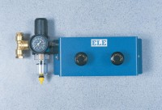 | Pneumatic Pressure Reducing Panel. Provides Two Independent Pressure Outlets 1000 Kpa Max.  Code: 26-1760  Product Group: Air/Water Pressure Systems - up to 1000 kPa  Comprising two constant pressure reducing valves with inlet water trap and pressure indicator. The unit allows a maximum output pressure of 1000 kPa. Maximum input pressure should not exceed 1400 kPa. The panel has an inlet connector to accept Nylon tubing from the air compressor and two 6 mm outlets for connecting Bladdertype Air/Water Pressure Assemblies. An outlet connector  is fitted for the connection of an additional panel using Nylon tubing to increase the total capacity of the system. This outlet is blanked off when not required.

