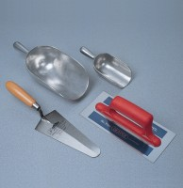 | Shovel - With flat blade  Code: 81-0240  Product Group: Scoops and Shovels

Further Information
**NOT AVAILABLE FOR SALE IN THE USA**

