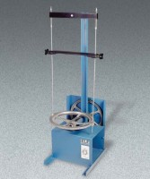 | Laboratory Sieve Shaker 110V 60 Hz  Code: 80-0455/02  Product Group: Laboratory Sieve Shaker  The new Laboratory Sieve Shaker is designed to accept up to eleven 8" (203 mm) diameter by 2" (50.8 mm) high or seven 12" (305 mm) by 3" (76.2 mm) high standard test sieves and cover.  The unit is fitted with a 1/4 h.p. motor and 30-minute timer.  110vAC, 60 Hz, 1ø.

Further Information
• Cost effective design for the efficient separation of materials.
• Accepts 8" (203 mm) and 12" (305 mm) standard test sieves.
• Built-in 30 minute timer.

Specification
Capacity. | Eleven 8" (203 mm) or seven 12" (305 mm) diameter sieves plus cover.
Timer. | Built-in 30 minute.
Motor. | 1/4 h.p.
Dimensions. | 14.5" w. x 18" d. x 48" h. (368 x 457 x 1219) mm.
Weight. | Net 73 lbs. (33.2 kg).

