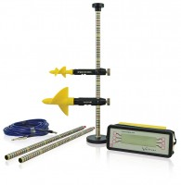 | Miniature Current Flow Meter Wading Set for Velocities 0.03 to 5 M/S.  Code: 520-265  Product Group: Flow meters  For velocities 0.04 to 5.0 metres/second. Consisting of current meter, revolution counter, wading rods, base and knob, 3 metres wading cable.

Further Information
All packed into carrying case 850 x 180 x 220 mm.

