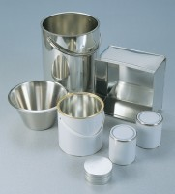 | Transport/Storage Container  Code: 81-3545  Product Group: Moisture Content Tin and Sample Containers

Further Information
**NOT AVAILABLE FOR SALE IN THE USA**

