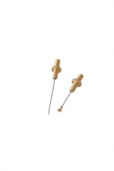 | EN Initial and Final Set Needle  Code: 38-2110  Product Group: Vicat Method  1.13mm diameter and 1.13mm diameter with special footing.

Standards
ASTM C187, ASTM C191

Further Information
**NOT AVAILABLE FOR SALE IN THE USA**

Spares/Consumables
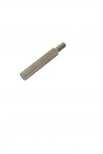 | Consistency Plunger  Code: 38-2010/10

