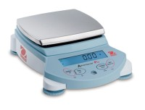 | Ohaus Electronic Balance - 210 g Capacity  Code: 88-1200/02A  Product Group: Ohaus Series Electronic Balances  Includes internal calibration and weigh-below hook.

Further Information
100-240V, 50/60 Hz.

