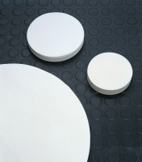 | Filter Paper - Fast  Code: 82-7861  Product Group: Filter Papers (Box of 100)  No. 55 x 400 mm diameter.

Further Information
**NOT AVAILABLE FOR SALE IN THE USA**

