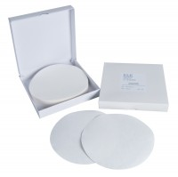 | Filter Paper Equivalent to Whatman No 5 150mm Dia Box of 100.  Code: 24-9250  Product Group: Filter Paper, ASTM/AASHTO CBR mould and accessories  Box of 100.

Standards
ASTM D1883, AASHTO T193

Specification
Grade | Coarse.
Size | 15 cm diam. (5.9â).
Weight | Net 8 oz. (22 7 g).

