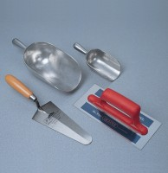 | Trowel - Gauging  Code: 81-0335  Product Group: Trowels and Floats

Further Information
**NOT AVAILABLE FOR SALE IN THE USA**

