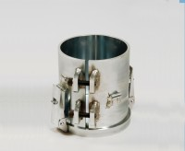 | PRD Split Mould and Baseplate  Code: 47-0450  Product Group: Percentage Refusal Density (PRD)

Standards
EN 12697-32, EN 13280-4, BS 598-104

Further Information
**NOT AVAILABLE FOR SALE IN THE USA**

