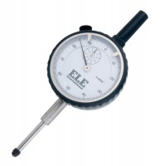 | Penetration/Swell Dial Gauge ASTM.  Code: 24-9184  Product Group: Expansion (swell) Test Equipment, In-situ CBR, Conversion of In-situ to Laboratory CBR, Penetration and measurement  1 in travel x 0.0005 in divisions. Complete with rack extensions and chisel edge anvil.

