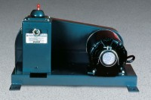 | Standard Vacuum Pump  Code: 88-3100/02  Product Group: Standard Vacuum Pump, Specific Gravity (Rice) Test with 6,000 gram Vacuum Pyknometer

Further Information
115vAC, 60 Hz, 1ø.

Specification
Pump | Two series-connected eccentric pumps; base-mounted.
Delivery | 0.3 microns of Hg; ultimate pressure in  leakproof system; 3 gal/min. (10 liter/min) free air displacement at 350 rpm.
Motor | 1/3 h.p.;V-belt drive; base-mounted.
Intake Port | 13 /32 â (10 mm) o.d.; takes 1/4â (6 mm) bore tubing.
Overall Dimensions | 18-1/2â w. x 10â d. x 10-3/4â h. (469 x 254 x 273 mm).
Weight | Net 46 lbs. (21 kg).

