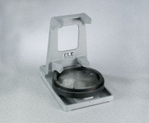 | 6" Cylinder Capper  Code: 34-6093  Product Group: 6" Cylinder Capper

Standards
ASTM C617, AASHTO T231

Specification
Frame | Aluminum alloy with integral handle and sample placement guides.
Capping Plate | Hardened, ground steel; 9/16â (155 mm) thick; removable for regrinding; rotates for even wear.
Guide Ring | Tapers to 6-1/8â (155 mm) diam. clearance;  removable.
Weight | Net 22 lbs. (10 kg).

