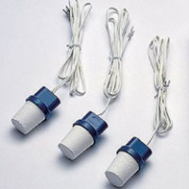 | Soil Moisture Block 2.7 m Lead  Code: 514-130  Product Group: Soil Moisture  2.7 Metre Long Lead

