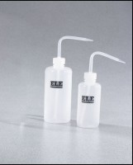 | Plastic Dispensing Bottle - 250 ml Capacity  Code: 88-6610  Product Group: Plastic Dispensing Bottles  8 oz. (250 ml) capacity.

Specification
Material | Conventional polyethylene; non-toxic, non-contaminating; withstands nearly all chemicals at room temperature for 24 hrs.
Temperature Tolerances | 176Â°F (80Â°C) maximum; -148Â°F (-100Â°C) brittleness.
Weight | Net 2 oz. (56 g).

