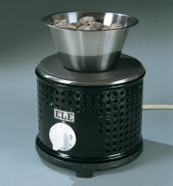 | Hotplate  Code: 78-2950/01  Product Group: Hotplate

Further Information
**Not available for sale in the USA**

Specification
Construction | Cast-iron top and base ventilated sheet-steel body
Nominal diameter | 200 mm
Maximum temperature | 500ºC
Rated power | 2000 W
Weight | 5 kg

