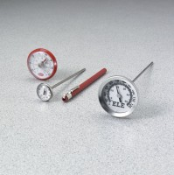 | Dial Thermometer, 50° to 500°F x 5.0° and 5° to 260°C x 5.0°.  Code: 88-4456  Product Group: Dial Thermometers  50° to 500°F x 5.0° and 5° to 260°C x 5.0°.

Specification
Construction | Dual-scale; 1/8â (3 mm) diam. Stainless steel stem with bimetallic element; adjustable zero; plastic face.
Accuracy | Â±1% when over 2â (51 mm) of stem immersed.
Dimensions | 1-3/4â (44 mm) dial diam. x 8â (203 mm) long stem.
Weight | Net 3 oz. (85 g).

