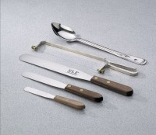 | Wire Saw  Code: 88-7600  Product Group: Wire Saw  Narrow.

Specification
Frame | Narrow type; one-piece metal with adjustable threaded screws, plated for rust resistance; supplied with wires only; 16â (406 mm) l. overall.
Cutting Section | 9â (229 mm) l.
Spare Wires | Six included.
Weight | Net 4 oz. (113 g).

