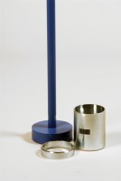 | Core Cutter 100mm Id By 130mm Long.  Code: 29-5300  Product Group: Core Cutter Apparatus

Standards
BS 1377

