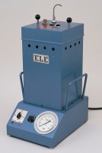 | Autoclave  Code: 38-3800/01  Product Group: Soundness of Portland Cement by the Autoclave Method  The autoclave provides high pressure steam curing of the specimens and is supplied with a safety valve pressure gauge and controlled heater unit. The pressure vessel is independently certified and certificated. A specimen rack with capacity for 12 specimens included. The unit conforms to the requirements of ASTM C151.  220-240 V 50/60 Hz 1ph

Standards
ASTM C151

Further Information
**NOT AVAILABLE FOR SALE IN THE USA**

Spares/Consumables
 | Lid Sealing Gasket  Code: 38-3800/13

