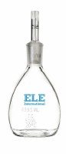 | Glass Specific Gravity Bottle - 25 ml Capacity  Code: 88-6300  Product Group: Glass Specific Gravity Bottles

