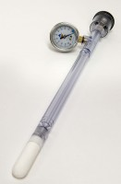 | JET Fill Tensiometer 150 mm  Code: 514-035  Product Group: Tensiometers  150mm Long

Further Information
Requires Part No 514-034

